9/26/2023

Database Management Systems

**Professor Feng**

# Lab3

Instruction

For this week’s lab, we’re going to be creating our own tables through either queries or through the phpMyAdmin tools available. I found it easier to create through SQL queries as it allows exactly what the structure is asking for, but if the table create tool is your preferred method that is okay too. For this lab screenshots after step will be required at the end to show to your works.

The first step is to create a table named “share” going from the following table:

“share” structure

|  |  |  |
| --- | --- | --- |
| **Field name** | **Type** | **Primary Key** |
| shrcode | CHAR(3) | Yes |
| shrfirm | Varchar(20) | Not null |
| shrprice | DECIMAL(6,2) |  |
| shrqty | DECIMAL(8) |  |
| shrdiv | DECIMAL(5,2) |  |
| shrpe | DECIMAL(2) |  |

As an example, for the screenshot, I’m looking for here, the following was taken from one of the tables that was imported last week, using the structure tab.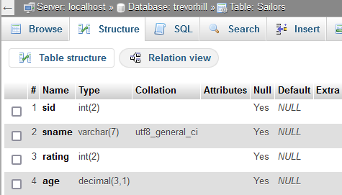

Screenshot: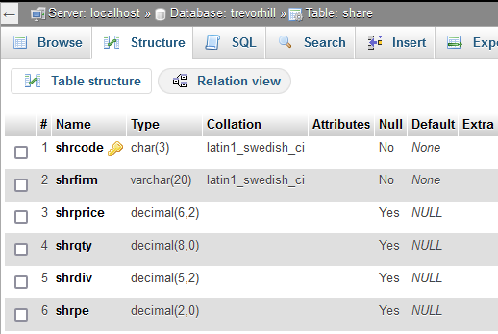

After the table is created, populate it with the values from the following table:

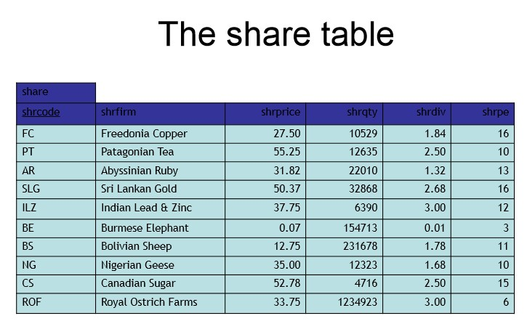

Screenshot:

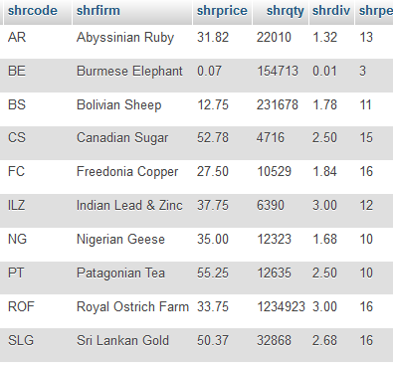

INSERT INTO share VALUES ('FC','Freedonia Copper',27.50,10529,1.84,16);

INSERT INTO share VALUES ('PT','Patagonia Tea',55.25,12635,2.50,10);

INSERT INTO share VALUES ('AR','Abyssinian Ruby',31.82,22010,1.32,13);

INSERT INTO share VALUES ('SLG','Sri Lankan Gold',50.37,32868,2.68,16);

INSERT INTO share VALUES ('ILZ','Indian Lead & Zinc',37.75,6390,3.00,12);

INSERT INTO share VALUES ('BE','Burmese Elephant',0.07,154713,0.01,3);

INSERT INTO share VALUES ('BS','Bolivian Sheep',12.75,231678,1.78,11);

INSERT INTO share VALUES ('NG','Nigerian Geese',35.00,12323,1.68,10);

INSERT INTO share VALUES ('CS','Canadian Sugar',52.78,4716,2.50,15);

INSERT INTO share VALUES ('ROF','Royal Ostrich Farm',33.75,1234923,3.00,16);

With your table now including the data that we are looking for the following queries are to be completed to finish off the lab:

1. List all the firms and their codes in the share table.

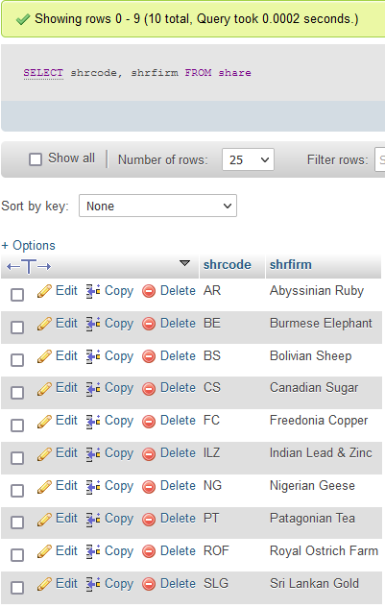

2. Get all firms with a price-earnings ratio less than 15.

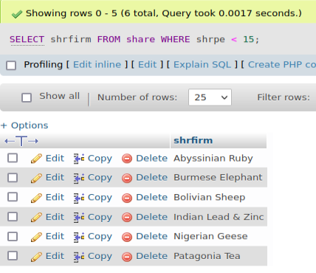

3. Report data on firms with codes of FC, AR, or SLG.

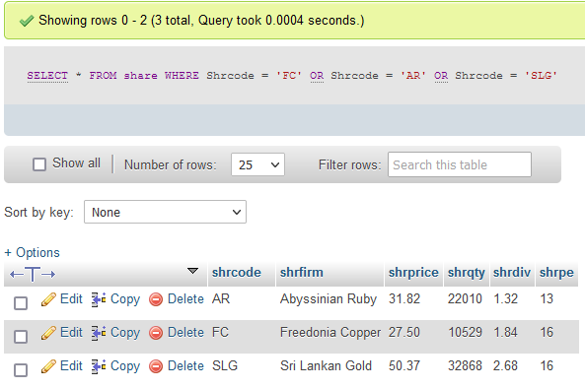

4. Report all firms other than those with the code CS or PT.

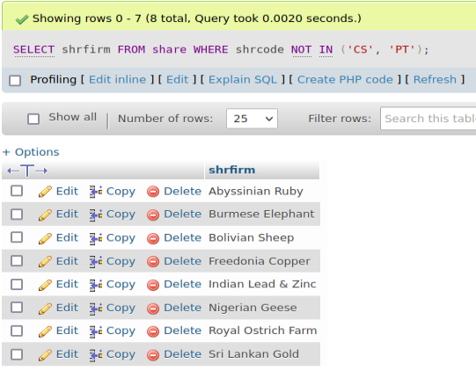

5. List all firms where PE is at least 12, and order the report in descending PE. Where PE ratios are identical, list firms in alphabetical order.

